Computer Associates International, Inc. (CA) offers its CleverPath™ portfolio of business solutions designed for organizations needing to fuel innovation and increase competitive advantage by leveraging their information assets. CleverPath Portal is an integrated, open and flexible web-based business workplace that provides the understanding needed for optimizing your business. CleverPath Portal and dashboard solutions (CleverPath™ Reporter and CleverPath™ Dashboard Option) integrate, aggregate, and visualize information in a personalized, intelligent and engaging environment, providing a medium for collaboration, business insight and effective decision-making.

Optimize Business and IT
Today, enterprises are challenged to deliver information that enables a rich level of business understanding and the ability to optimize business processes and IT services throughout the entire decision life cycle.

Business is moving at an ever accelerating pace and information technology is more seamlessly integrated with business processes than ever before. Your employees, vendors, partners and customers expect access to the right information when and where they need it, in the appropriate form, enabling faster and better decisions in order to optimize their business processes. IT must deliver effective business services that support enterprise goals and strategies. Most organizations, however, do not have the time to undertake lengthy integration projects in order to address a specific business challenge with information from multiple business processes.

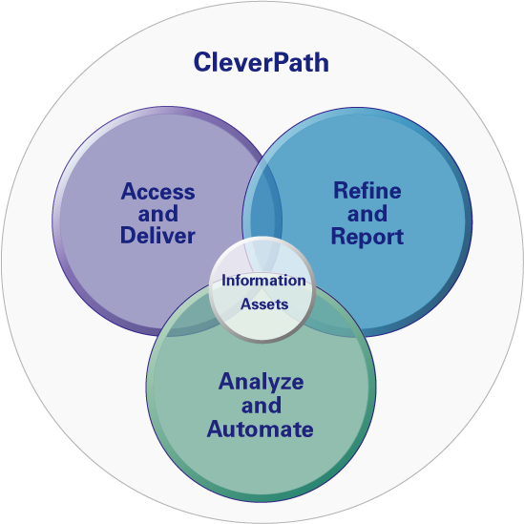
Business services optimization enables organizations to align business processes with IT services, and ensures that these services are delivered in the most cost-effective and efficient manner to meet overall goals. IT services are mapped to business needs and prioritized so that value is delivered for projects within defined time, resource, and budget guidelines. IT can then deploy and support these services to ensure that required compliance, financial, and service level objectives are achieved.

CleverPath Portal and dashboard solutions make it easy for customers, partners, employees, and IT – at all levels across the enterprise – to access a broad range of information resources, better understand their business, and together with CleverPath Aion solutions, apply knowledge and predictive intelligence to improve and optimize business effectiveness.
Providing insight into business activities and business processes, CleverPath Portal and dashboard solutions are producing B2E, B2B and B2C results for customers across the globe. CleverPath Portal and dashboard solutions aggregate both structured and unstructured data assets, so you can leverage information and applications toward optimizing the processes that support your business. Integration of data, applications, business processes and visualization technology provide a unique user experience that delivers rapid time-to-value by providing knowledge that is complete, relevant and personalized for each user, while minimizing resources. Using Java, J2EE and other open standards enables modular yet integrated solutions for incremental and expandable deployment.

Product Strategy
CleverPath solutions are recognized in the industry as providing the technology for advanced business value systems that enable organizations to monitor their business activity and add fuel to business process optimization through the display of dashboards containing key performance indicators (KPIs) and alerts.

To ensure the continued success of CleverPath Portal and dashboard solutions and to address changing market and business demands, CA has and will continue to support these technologies as part of our ongoing effort to provide complete, integrated and open solutions that benefit both IT and Lines of Business (LOB) through broader alignment and collaboration.

Working with key customers and industry thought leaders, CA developed the set of requirements for the latest set of CleverPath Portal and dashboard solutions to address the current and emerging business challenges inherent to effectively supporting and managing business processes on-demand.

CleverPath Portal has been designed and architected to satisfy the requirements of CA customers and for usage as embedded technology within Computer Associates management software solutions and third-party partner products. The modular component-oriented architecture has been developed to provide both a rapid out-of-the-box experience and an environment where business and IT management applications can be readily constructed and deployed.


The CleverPath Portal product strategy focuses on the following key areas:

- Reporting and visual display supporting business activity monitoring and business process management
- Open, configurable and customizable deployment
- Integrated portal-oriented content management and information delivery
- Standards and versatility

Reporting and Visual Display Supporting Business Activity Monitoring and
Business Process Management
Understanding your business through Business Activity Monitoring (BAM) is a key focus of CleverPath Portal and dashboard solutions. BAM enables a visual status of critical business processes and provides support for on-demand viewing of current business metrics and key performance indicators. While visual representation of BAM information is important, additional support for timely alarms and alerts is required to connect business process understanding with action toward business process optimization.

BAM enables organizations to effectively monitor business processes and engage in business process management (BPM) and automation. BPM encompasses the management of explicit business processes from beginning to end – for example, insurance claims processing from the time a claim is made to when the payment is completed.

CleverPath Portal and dashboard solutions complement BPM initiatives by providing important aggregation, visualization and refinement technologies that work with CleverPath Aion solutions, thereby enabling a broad spectrum of business process management capabilities.


Regulatory requirements such as Sarbanes-Oxley and BASEL II, under which certain processes must be documented and IT controls verified, accentuate the need for dashboard display of business process status for compliance with key regulations.

Open, Configurable and Customizable Deployment
CleverPath solutions are designed for both deployment out-of-the-box and as a basis for more advanced configurations and deployments where customers or third parties are building solutions using CleverPath technology as a common services foundation.

Integrated Portal-Oriented Content Management and Information Delivery
Increasingly, business users need to manage, review and approve documents before they are published to internal and external consumers. CleverPath Portal includes portal-oriented content management and approval workflow services, focused on documents and other content that is bound for delivery in CleverPath Portal.

Standards and Versatility
As IT environments become more comprehensive and complex, software solutions must not only provide required functionality, they must also support open standards and provide extensible architectures that enable a smooth fit within the IT infrastructure. CleverPath Portal is a Java-based solution that has a long history of openness and support for industry standards. CleverPath Portal and dashboard solutions are and will continue to be deployable on a wide array of hardware and software platform combinations including Windows, Linux and Unix operating systems, open-source and other application servers, multiple browsers and leading database management systems.

CleverPath Portal and dashboard solutions will continue to embrace and implement features leveraging key Java, J2EE, Web services and other common standards, including JSR 168 and WSRP, providing versatility and compatibility with today’s intricate enterprise IT environments and integration with complementary technologies and solutions.

Development Plans
Delivering on our product strategy, CleverPath Portal and dashboard solutions are evolving rapidly through several new releases. Recently, CleverPath Portal r4.7 introduced new portal-oriented, integrated content management features to effectively manage, review and approve documents bound for publication in CleverPath Portal.

CleverPath Reporter r4.2 and CleverPath Dashboard Option r7.1 are currently available and focus on customer and CA internal use requirements for the effective delivery of executive and department dashboards that typically incorporate reports, scorecards, key performance indicators (KPIs) and alerts. CleverPath Portal r12 introduces integrated reporting and other advanced capabilities designed to take the next step in leveraging industry standards for a more extensible, open and customizable solution.

CleverPath Portal r4.7
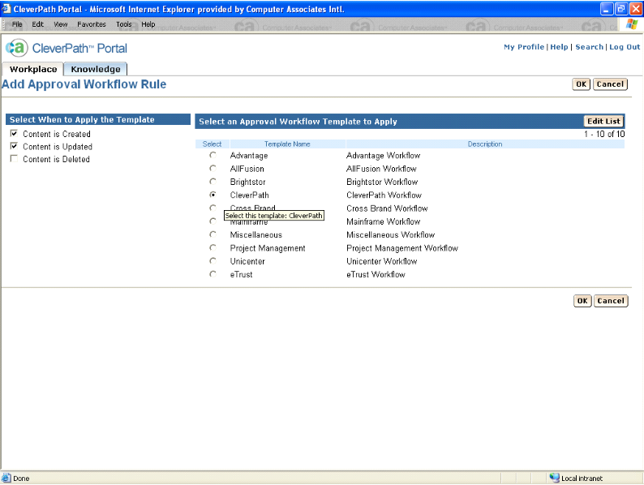
CleverPath Portal r4.7 is currently available and includes comprehensive new portal-oriented document and content management services in addition to significant usability improvements, customer-driven enhancements and upgraded platform support to the core Portal functionality.

Integrated portal-oriented
content management
With a focus on management, review, approval and publication of content bound for delivery CleverPath Portal r4.7 includes a preconfigured content management services workplace with specific portlets designed for content owners to easily add, review, modify and approve document-oriented content for publication into the CleverPath Portal knowledge library.

Content management services include management, versioning and history of content; extraction of metadata from existing document property information; user-defined metadata; WebDAV support; a workflow system for review, approval and publication to local or remote portals; search and advanced search; subscription and notification; and a permission-based security model based on Access Control Lists (ACL) to manage content access for users and workgroups defined in CleverPath Portal.

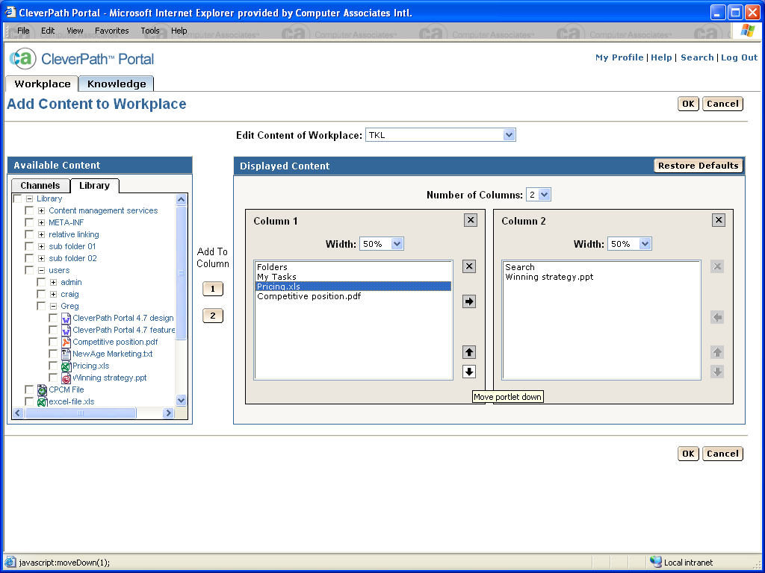
Usability improvements
Based on an extensive usability study conducted with CA customers and CA internal portal users, CleverPath Portal r4.7 includes a number of usability and user interface (UI) improvements designed to provide a more intuitive and consistent user experience. These improvements are primarily focused in content-oriented areas and include use of tabs, row highlighting in lists, more extensive paging controls in search lists, portlet titling, updated layouts and a new workplace configuration interface.

Other enhancements
CleverPath Portal r4.7 includes upgraded platform support and many other enhancements – as a direct result of customer requests – that expand the powerful capabilities of CleverPath Portal and the environments in which it operates.

CleverPath Dashboard Option r7.1

Dashboard Component Development and Deployment

CleverPath Dashboard Option r7.1 is currently available and supports the building and deployment of visual key performance indicators (KPIs) as portlets. A highlight of this release is the customer requested function of enhanced ActiveX processing for building interactive portlets. In addition, this release introduces ADO .Net server based data access capability, enhanced charting through interactive maps and an interface leveraging SOAP to call and consume web services.

CleverPath Reporter r4.2

Server Based Report Development and Deployment
CleverPath Reporter is a multi-platform server based reporting engine. CleverPath Reporter r4.2 is currently available and delivers Linux server support, native Ingres open-source database support, multi-byte certification and an embedding kit supporting reporting requirements across all CA solutions.

CleverPath Portal r12
CleverPath Portal r12 embraces new industry standards providing flexibility, extensibility and the basis for customization by external customers and to readily support 3rd party embedded usage. Further, additional Computer Associates management software solutions are embedding CleverPath Portal as the foundation technology for their web interface because of its ability to aggregate and personalize content in a powerful, flexible framework.
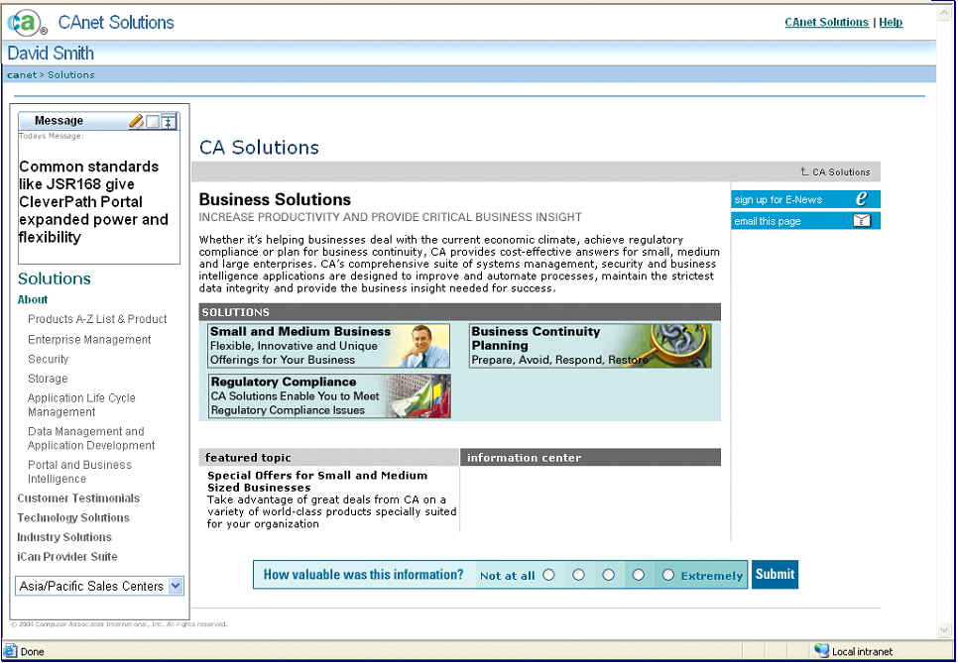
While management software is seemingly a different type of usage from typical line-of-business portal/dashboard applications it is becoming increasingly obvious that systems management, storage management, security management and business process management software are actually key business applications for enterprise IT departments just as corporate communications, human resources, operations management, customer service, or financial reporting are very specific business applications for their lines of business.

CleverPath Portal r12 requirements are driven by both the customer market as well as our internal embedded usage in Unicenter, eTrust, BrightStor and CleverPath Aion solutions.

Extended Architecture
CleverPath Portal r12 leverages open industry standards and extends the current architecture by implementing a portal framework that delivers functionality and services necessary for such a key component in the IT infrastructure. The extended architecture operates within a multi-tiered environment that supports the presentation layer, a business layer, and a data integration layer.

Utilizing both open standards and existing technology whenever possible, CleverPath Portal r12 is a well-behaved Web application that uses J2EE components and follows established best practices for Web applications. Deployed on an application server, CleverPath Portal r12 resides within its own web application context and provides session management. Also, within its multi-tiered architecture, CleverPath Portal r12 embraces J2EE APIs for standard interfaces such as the Java Authentication and Authorization Service (JAAS) for user management and security while using Enterprise JavaBeans (EJBs) for business logic and management services.

Leveraging the most advanced open standards allows CleverPath Portal r12 to deliver enhanced messaging, interoperability, security, user management and other services. The J2EE Web architecture provides CleverPath Portal r12 with improved performance, and delivers a secure open infrastructure with extensive scalability, reliability, availability, maintainability and manageability.

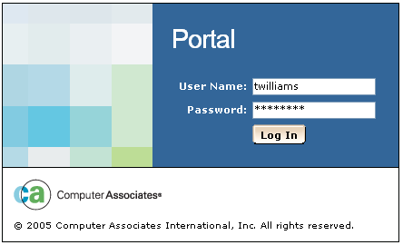
User Management and Security
Because CleverPath solutions are in the business of delivering user-based, role-based and group-based business information, it is important that they leverage corporate user management solutions. Computer Associates has the advantage of our experience and market leadership in security solutions with our eTrust technologies and with CleverPath Portal r12 we leverage that advantage. In addition, industry standards such as Java Authentication and Authorization Service (JAAS) offer interoperability and extensibility.
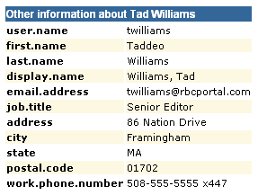
CleverPath Portal r12 reduces the duplication of user and group administration by leveraging eTrust technology to implement an externalized user management model. Using the eTrust embedded identity and access management component enables CleverPath Portal r12 to integrate with the included default user management system or with existing LDAP-compliant systems such as CA’s eTrust Directory or Microsoft Active Directory. The benefit to this integration is direct authentication of users via the enterprise directory while enabling single sign-on to applications that share the corporate authentication resource.

In addition to supporting groups defined in the enterprise directory, CleverPath Portal r12 supports the addition of dynamic groups for more community-oriented user organization and information delivery. A policy-based permission model allows greater flexibility for securing access to content assets while also providing the increased granularity of an Access Control List (ACL) permission structure when needed.
Content Delivery

UI and User Centered Design
Computer Associates product development related to information display and page layouts is based on a use case design (UCD) methodology that recognizes multiple user roles and associated use case requirements for information interaction. The CleverPath Portal r12 user interface (UI) follows Computer Associates UI standards and is implemented leveraging industry practices and technologies. Many of the key CleverPath Portal r12 UIs have been evaluated and tested by portal users during the design and implementation phases of the project. The result is a UI that is intuitive for both business and IT users, enabling the ability to readily create portal applications comprised of a combination of web pages, portal pages and portlets that range from fixed, shared portal pages to completely personalized pages.

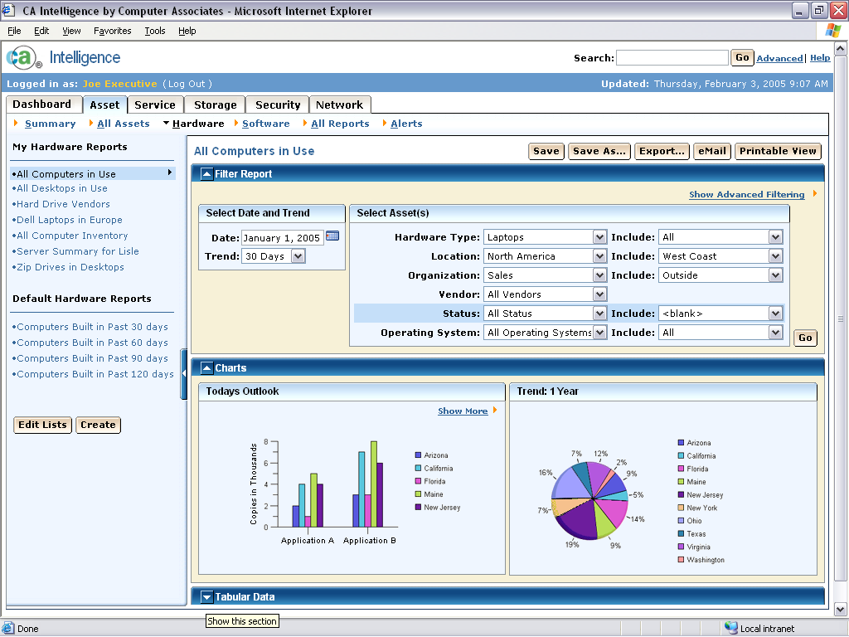
Powerful Portlets
Portlets are at the heart of any portal and provide the presentation layer for the information systems they represent. Aggregating portlets into pages enables users and organizations to provide the appropriate integration of information and applications, and context for effective business operations. Two new portlet standards have become finalized with the potential to vastly increase the power and flexibility of portlets.

Java Community Process JSR 168: Portlet Specification defines a method of creating portlets that embed control over their own configuration and operations within the portlet. This standard supports interoperability and the deployment of portlets that can be consumed by any portal server providing a compliant JSR 168 portlet container, effectively enabling portable portlets.

OASIS Web Services for Remote Portlets (WSRP) Specification describes a Web services API for producing Web services-based portlets and consuming these portlets even when they are executing on a remote server.

WSRP support includes both the ability to expose portlets as a WSRP producer and the ability to consume WSRP portlets hosted on other servers.

Computer Associates development team has researched and tested these new standards in our labs over many months, identifying the strengths and challenges associated with each standard. CleverPath Portal r12 supports and takes advantage of both the JSR 168 and WSRP standards.

Shared and Personal Portal Pages
The portal page – also known as workplace – is well accepted as an information delivery mechanism because it aggregates applications and content, both structured and unstructured. The portal page addresses shared views of information as well as subscribed or personalized views of information. Shared pages – that are created by the page owner and pushed to the targeted consumers – facilitate efficient aggregation and distribution of content to groups and individual users. Pages can also be personalized and portlets configured by end consumers, providing content appropriate for an individual’s role-based needs while filtering out irrelevant information. CleverPath Portal r12 elevates the portal page concept by providing more page options including creation, layout, management and navigation capabilities that match the expanding requirements of organizations that rely on portals for effective information delivery in support of business process optimization.

Reporting and Dashboards
The delivery of effective information in portlets and report pages shares much in common. Just as a report may be made up of multiple components, such as tables, charts, headers, footers, etc., the same applies to information display in a screen-based workplace. As common report building is often constrained by horizontal bands, common portal delivery is typically constrained by vertical columns. CleverPath Portal r12 seeks to reduce these constraints and leverage the commonality of report composition and portal page composition into a model that leverages the strengths of both.

Building interactive dashboard visualizations that include tables and charts follows the same user-focused development model as that used for CleverPath Portal r12 portal pages. Independent of server processing, report and dashboard creation include both “What You See Is What You Get” (WYSIWYG) and API based interfaces. The GUI report designer provides a palette interface for the layout of display objects, while an XML schema and APIs provide the ability for programmatic report definition, creation and execution.

CleverPath Reporter Builder and Server functionality are included as key integrated components of the CleverPath Portal r12 package. Report and dashboard content rendering supports a variety of output deployment formats, including Adobe PDF, and offers web deployment, including linking and drilling into and between content objects, prompting and filtering.

Content Management Flexibility
Building upon CleverPath Portal r4.7 document and content management services, CleverPath Portal r12 delivers a single content repository supporting all major document types and enabling document uploads and downloads, check-out and check-in, history and versioning, search, extracted and user-defined properties, subscription and notification, content approval workflows and publication for usage on portal pages.

Another new standard, Java Community Process JSR 170: Content Repository for JavaTM technology API provides specifications for a common set of interfaces to access content repositories. JSR 170 is expected to receive final approval in mid-2005. The Computer Associates Research and Development team is closely monitoring the progress of JSR 170 approval and is preparing an API implementation modeled on JSR 170 for CleverPath Portal r12. This standards-based interface is designed to provide openness flexibility for programmatic access to the CleverPath Portal content library. The degree of compatibility and compliance of the CleverPath Portal r12 content repository API and JSR 170 depends on the timing of final approval of JSR 170 and publication of its testing kits.

CleverPath Portal r12 also continues to provide the standard WebDAV interface for access to library content within the repository.

Advanced Search
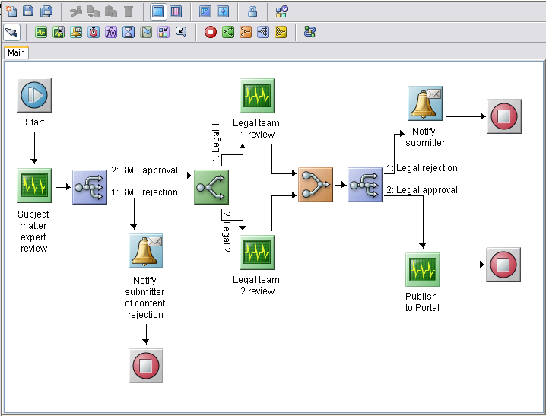
CleverPath Portal r12 search capabilities are further extended, embracing advancements in search engine technology including additional indexing, categorization, spidering, metadata search and full text search enhancements. For example, indexes can be refined using new filters that can be applied when crawling web sites or file shares, in order to include or exclude certain file types, file names or directory structures.

Workflow
CleverPath Portal r12 embraces a powerful new CA workflow engine supporting approval processes for content management and portal page distribution to groups and users. The new workflow engine enables these business processes to be defined using a highly intuitive graphical environment and provides automation of business processes during which documents, information or tasks are passed from one participant to another in a pre-defined flow. User interaction with the workflow engine is via browser-based forms deployable through the Portal.

Summary
Portals, dashboards and web-based reports have become the standard browser-based interface to key business processes and other enterprise content by integrating and aggregating information into a personalized, intelligent and engaging environment that can be easily accessed. Timely access to the right information in a secure, collaborative environment enables better understanding of the business and more effective decision-making. Meeting the needs of both external and internal CA customers requires an advanced portal architecture that takes advantage of common industry standards for reliability and extensibility.

CleverPath Portal and dashboard solutions meet these requirements via an extended infrastructure designed for effective content delivery. Computer Associates sees this technology solution set playing a critical role in helping organizations optimize their businesses processes toward delivering more effective and aligned business and IT services.

Computer Associates is committed to the continued support of these technologies for both line-of-business, and IT-focused solutions, to ensure that the needs of our clients, internal and external, are met.

